Technical Description of the Posnow
Cash Register
By Aisha Shazar
City College of New York
Instructor: Susan Delmare
November 07, 2022

Author’s note
This paper was prepared for English 21007 taught by Professor Susan Delamare.
Questions concerning this paper should be addressed to: Contact: Ashazar000@citymail.cuny.edu
Table of Contents
Abstract ..........................................................................................................................................3 Introduction .....................................................................................................................................5
Background .....................................................................................................................................6 List of Parts and Functions .............................................................................................................7
Conclusion ......................................................................................................................................8
List of Figures .................................................................................................................................9
References .....................................................................................................................................10

Abstract
Cash registers have evolved a lot since their initial synthesis in the late 1800s. They have many aspects and functions to them which will be discussed. As technology has advanced so has the conveniency of products including cash registers. This technical description will discuss the Posnow cash register. It will include its historical background, list and parts, along with the functions.

Introduction
Cash registers are commonly used in today's society run by capitalism. They are multicomponent machines including parts such as cash drawer, scanner, printer, and more. The first cash registers were created in Ohio by a man named James Jacob Ritty. He ended up selling his invention which was turned into a company called National Cash Register by the buyer (Terell, 2020). The original date of the creation of the company was November 4th, 1879 (Terell, 2020). Modern day cash registers are much easier to use and way less complicated. This invention has gone through many critical changes as its development and usage bled into the 21st century from the 20th century. Technological advancements have made the process of handling money convenient; providing exact change for the register person. One of the leading brands for cash registers in the industry is Posnow, the company was founded in 1992 and deals with a variety of technology such as softwares.

Historical Background
Posnow has dedicated their company to the advancement of their products and services as technology progresses. They appeal to many business corporations for this reason as they are well known producers in the industry. Fast food corporations in particular consume many Posnow products as they aid their “fast service” with fast technology. This technology includes wireless car readers, barcode scanners, along with touchscreen cash register machines, and bluetooth receipt printers. Posnow has continued to exceed the limit of the cash register machine since they began making them.

Lists and Parts Functions
The Posnow cash register system comes in a complete set of parts that work together to complete a transaction. The Pro-C15W Point of Sale Terminal or in other words the register screen is also connected to the drawer (Figure 1). The screen includes the port for the power cable and power brick. The screen has to be assembled to the base via a slot and then four screws that need to be tightened (Figure 2). The drawer has multiple compartments that hold change and can open manually through the screen or it can be opened using a key in the front of the drawer (Figure 1). It automatically locks after a transaction is completed. The entire drawer is made out of metal and measures at 16x16x3 inches (Posnow Setup guide, p 2). There is a power cable that connects on the side of the screen. Once the power cable is connected inside the terminal side, then the register system is connected to the internet (Posnow Setup guide, p 5). After all these parts are connected the system is ready to be used.

Figure 1: The cash register includes four different functional pieces which each have their own specialties that work together to form the cash register system.

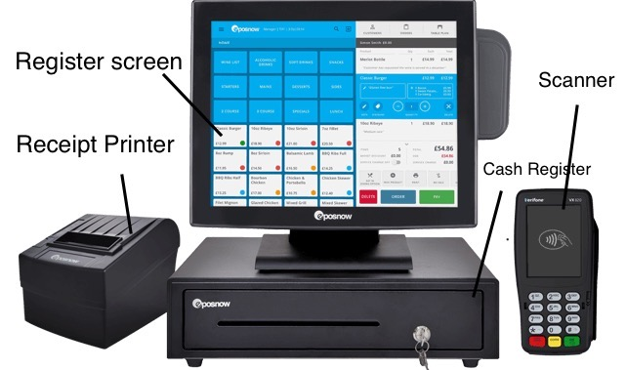
Posnow Set up guide, Epos Now, 2022,
https://www.eposnow.com/assets/Instruction-Manual-W-O-set-up-wizard.pdf

Figure 2: Connecting Screen to Base

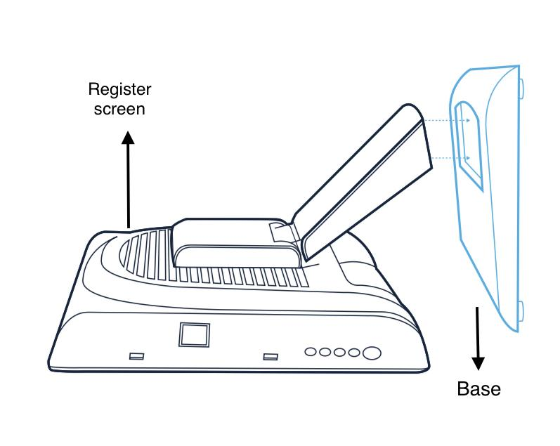

Posnow Set up guide, Epos Now, 2022,
https://www.eposnow.com/assets/Instruction-Manual-W-O-set-up-wizard.pdf

Cash register screen:
That includes the screen which allows the person taking the order to add the items that the customer is ordering manually. Allowing the option to choose payment method whether it is cash or card. If it is cash.
Cash drawer:
The drawer underneath the screen opens up allowing you to remove the correct amount of change for the customer. It has multiple compartments to hold change such as, pennies, quarters, dimes, nickels, along with bills.
Card reader:
If the payment is through the card the card reader which is a separate feature from the screen scans the chip and allows payment to be made.
Receipt printer:
Depending on whether or not the customer would like a receipt the printer will print it.
Scanner:
Another part of the system is the scanner which is used to manually scan items which can save time in comparison to manually entering the item on the screen, it connects into the register screen as well.
Power cable: The power cable is what connects the entire register system to the electricity and turns on the system, it is plugged into the terminal side of the screen.
Wifi cable: The wifi cable also connects into the terminal side of the screen and allows the machine to make wireless transactions.

Conclusion
In the past few decades fast food restaurants, clothing stores, and many other companies all have something in common aside from their capitalistic drive to expand. That common factor is a cash register. In order to carry out purchases of goods in stores, cafes, and restaurants it is a necessity. Therefore the cash register industry in itself has expanded as the need for registers has risen exponentially with the increase of businesses all across the globe. As the need for cash registers increased so did its advancement in terms of accessibility, continuity, and effortless use. Most registers now are touch screens allowing easier transactions for the customer and the person carrying out the transaction. All these different parts of the POSnow cash register are what make it a great competitor in the cash register developers’ world. It’s perfectly made to adapt with the modern demands of the consumer industry.

List of figures

Figure 1: Posnow Cash Register......................................................................................................5
Figure 2: Posnow Screen and base………………………………………………………………...6

References
“About Us.” POSNow, 24 Sep. 2022,
https://www.posnow.com/about-us/.

“Cash Register.” Cash Register - Ohio History Central,
Cash Register - Ohio History Central.

“Posnow Set up guide.” Epos Now, 2022,
https://www.eposnow.com/assets/Instruction-Manual-W-O-set-up-wizard.pdf

